|  |  |
| --- | --- |
|  | Data set Exploration Part 4 |
|  |  |
|  |  |

In the fourth phase of the project, I delved into Inferential Analysis to analyze relationships among finer questions in the IBM HR Analytics Employee Attrition dataset. The report meticulously details analysis of regression and correlation as well as Did our FINER research questions work together to examine relationships among variables that will help to build a coherent and cohesive analysis? And the complete report on IBM Employee Attrition will be here.

**Data set Introduction:**

The "Employee Attrition" dataset is a synthetic dataset created by IBM for the purpose of simulating HR analytics data. It is vital to highlight that this dataset is entirely fictional and does not represent actual employee data. It contains a variety of employee-related variables, such as demographics, work-related data, compensation-related information, and employee satisfaction metrics.

It described its origin, purpose, and inherent limitations, mainly emphasizing its fictional nature and how this could diverge from real-world employee data. This understanding forms the basis of our analysis.

**Dataset Description:**

***Source:***

The dataset we use for this study is made by IBM to explore variations in employee attrition. It was created to emulate a normal HR analytics dataset but is not based on actual employee data.

https://www.kaggle.com/datasets/pavansubhasht/ibm-hr-analytics-attrition-dataset

***Motivation:***

The aim of my studying this dataset is to find out more about those factors that could affect employee attrition within a company. A company’s performance, staff satisfaction, and overall efficiency can be greatly affected by employee attrition, which is the term for when employees leave the job. This dataset’s analysis allows one to study the relationships between different employee-related factors and attrition rates, helping companies make choices based on data that increase employee retention and job satisfaction.

**Data Dictionary:**

Here is a data dictionary for the dataset, including statistical variable types, descriptions, and, where applicable, ranges and limitations:

|  |  |  |  |  |
| --- | --- | --- | --- | --- |
| # | **Variable Name** | **Data Type** | **Description** | **Range / Limitations** |
| 0 | Age | Numeric | Age of the employee | Typically ranges from 18 to 65 years. |
| 1 | Attrition | Categorical | Employee attrition (Yes/No) | Binary: 'Yes' for attrition, 'No' for no attrition |
| 2 | Business Travel | Categorical | Frequency of business travel | Categorical: 'Travel_Rarely', 'Travel_Frequently', 'Non-Travel'. |
| 3 | Daily Rate | Numeric | Daily rate of pay | Varies based on the company's pay structure. |
| 4 | Department | Categorical | Department where the employee works | Categorical: 'Sales', 'Research & Development', 'Human Resources' |
| 5 | Distance from Home | Numeric | Distance from home to workplace | Measured in miles. |
| 6 | Education | Numeric | Employee's education level | Numeric scale: 1 (Below College) to 5 (Doctorate). |
| 7 | Education Field | Categorical | Field of education of the employee | Categorical: 'Life Sciences', 'Medical', 'Marketing', etc. |
| 9 | Gender | Categorical | Gender of the employee | Categorical: 'Male' or 'Female'. |
| 10 | Hourly Rate | Numeric | Hourly rate of pay | Varies based on the company's pay structure. |
| 12 | Job Level | Numeric | Level of the employee's job | Numeric scale: 1 (Entry Level) to 5 (Manager/Director). |
| 13 | Job Role | Numeric | Role or position of the employee | Categorical: 'Sales Executive', 'Research Scientist', etc. |
| 14 | Job Satisfaction | Numeric | Satisfaction level with the job | Numeric scale: 1 (Low) to 4 (Very High). |
| 15 | Marital Status | Categorical | Marital status of the employee | Categorical: 'Single', 'Married', 'Divorced'. |
| 16 | Monthly Income | Numeric | Monthly income of the employee | Varies widely based on job roles, experience, etc. |
| 18 | NumCompaniesWorked | Numeric | Number of companies the employee has worked for | Typically ranges from 0 (current company is first) to a higher value. |
| 19 | Overtime | Categorical | Overtime work (Yes/No) | Binary: 'Yes' for overtime, 'No' for no overtime. |
| 20 | Performance Rating | Numeric | Performance rating of the employee | Numeric scale: 3 (Average) to 4 (Excellent). |
| 21 | Monthly Rate | Numeric | Monthly rate of pay | Varies based on the company's pay structure. |
| 22 | Percent Salary Hike | Numeric | Percentage salary hike in the last year | Measured as a percentage. |
| 23 | Relationship Satisfaction | Numeric | Satisfaction level with work relationships | Numeric scale: 1 (Low) to 4 (Very High) |
| 24 | Stock Option Level | Numeric | Level of stock options held by the employee | Numeric scale: 0 (None) to 3 (High). |
| 25 | TotalWorkingYears | Numeric | Total years of work experience | Varies based on employee's career duration |
| 26 | TrainingTimesLastYear | Numeric | Number of training times attended last year | Typically ranges from 0 to a higher value. |
| 27 | Work Life Balance | Numeric | Work-life balance satisfaction | Numeric scale: 1 (Bad) to 4 (Very Good). |
| 28 | YearsAtCompany | Numeric | Years at the current company | Varies based on employee's tenure. |
| 29 | Years in Current Role | Numeric | Years in the current job role | Varies based on employee's role stability. |
| 30 | YearsSinceLastPromotion | Numeric | Years since the last promotion | Varies based on promotion history. |
| 31 | YearsWithCurrManager | Numeric | Years with the current manager | Varies based on managerial relationship. |

**Dataset Assumptions, Extra Data Requirements:**

Based on the nature of the dataset, several key assumptions have been identified:

* The dataset is entirely fictitious, and the exact collection process and timing cannot be verified.
* It is unclear whether the dataset is a subset of a larger dataset or represents an entire employee population. This has implications for generalizing our results.
* Measurement units for variables like "Age," "MonthlyIncome," and "HourlyRate" are not explicitly defined.
* Assumptions have been made about missing data: that missing data is not highly skewed and is absent randomly.
* No additional data is required for this analysis, as the provided dataset is sufficient for our goals.

**Univariate Statistics Performed:**

In this phase, I conducted univariate descriptive statistics on a selection of eight variables from the dataset, striking a balance between quantitative and categorical types.

Quantitative Variables:

* HourlyRate
* DailyRate
* DistanceFromHome
* JobLevel
* PerformanceRating

Categorical Variables:

* Department
* JobRole
* EducationField

Here are some screenshots of excel file I have done

* For Quantitative Variables

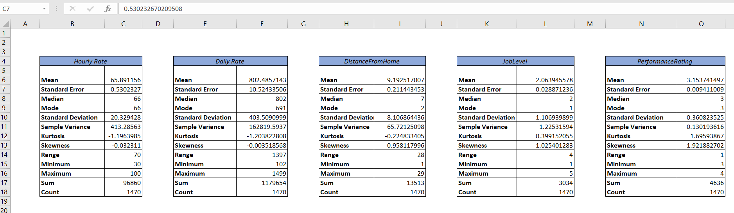

* For Categorical Variables

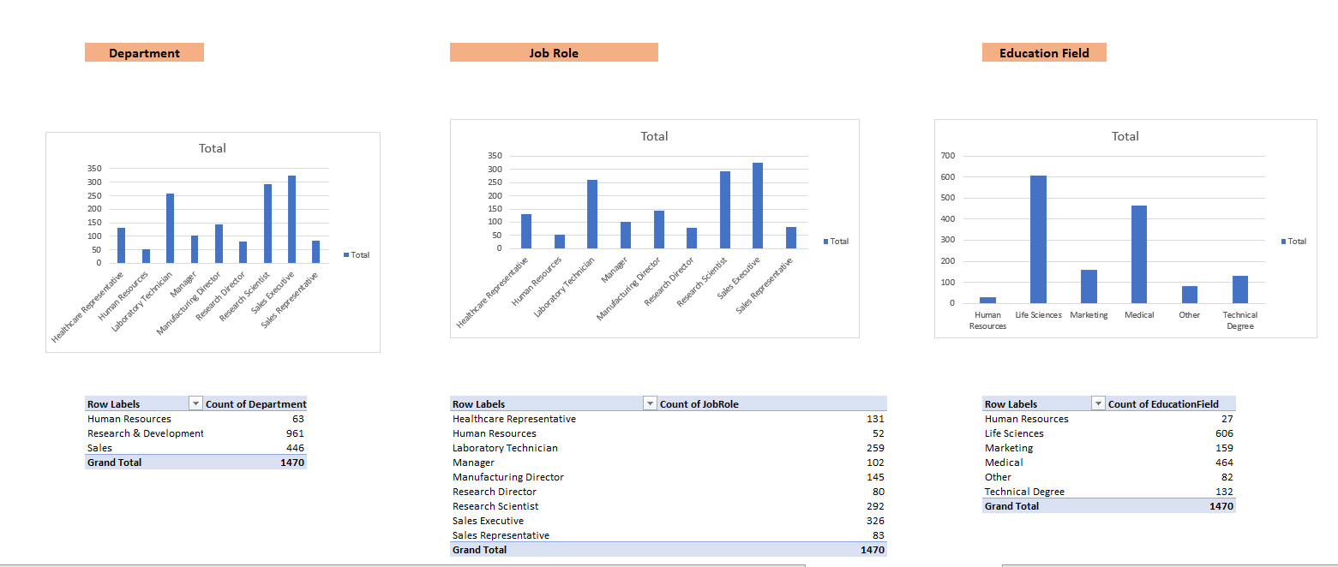

**Univariate Statistics Performed:**

All univariate descriptive statistics have been carefully presented in the report using appropriate visualizations, including tables, histograms, and scatter plots. The summary of statistics is depicted in the following tables and figures:

Include tables, histograms, and scatter plots displaying the univariate statistics for each of the chosen variables, ensuring that the presentation is clear and informative.

Here are some screenshots of excel file I have done

* For Quantitative Variables

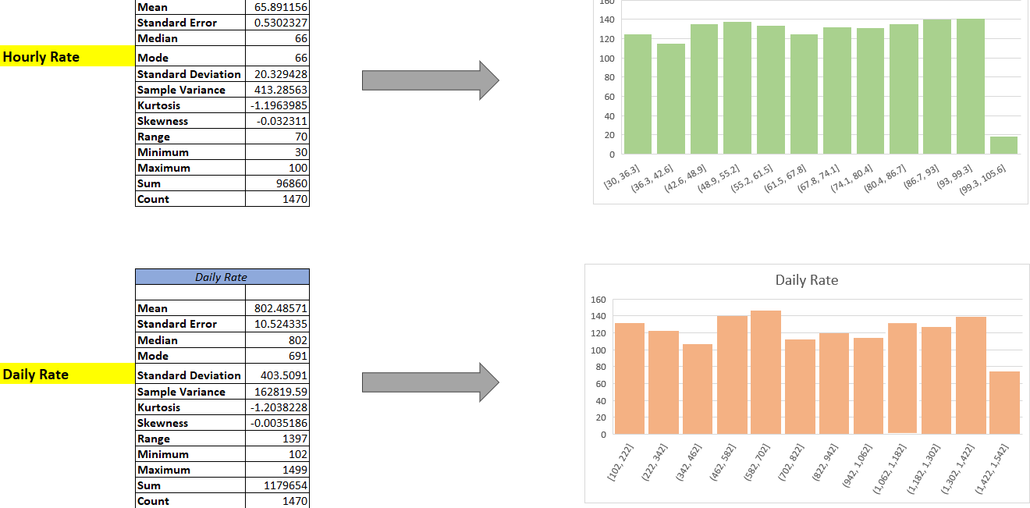

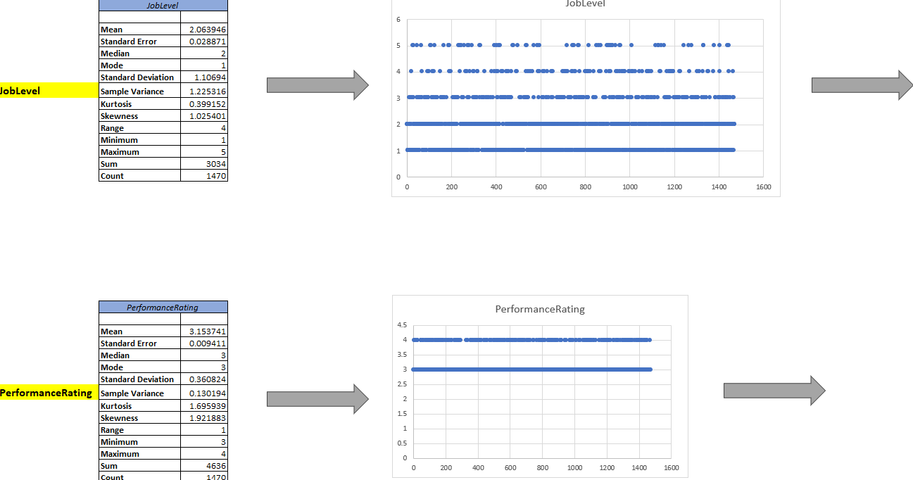

* For Categorical Variables

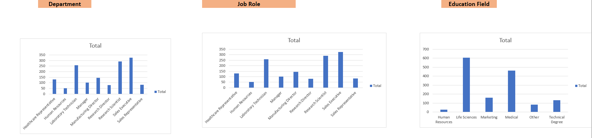

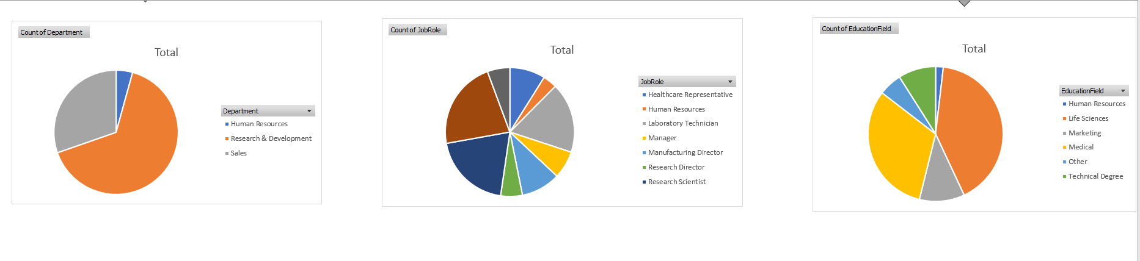

**Suggested Outliers Identified:**

During the analysis, I reviewed the quantitative variables for potential outliers. However, it's noteworthy that no significant outliers were identified within the dataset. While some variables showed slight skewness, no values were deemed as outliers requiring exclusion from the analysis.

This mean my dataset provided by IBM is too ideal.

Here are some screenshots of excel file I have done to check outlier

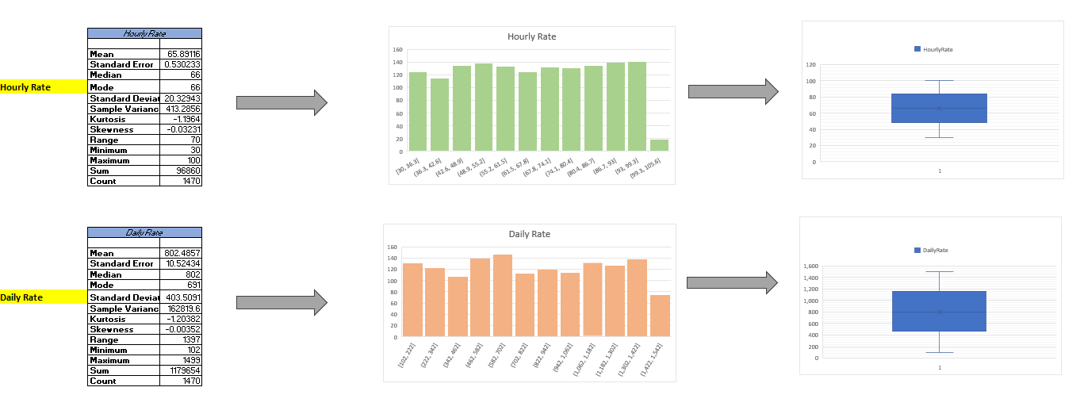

**Cleaning Decisions Explained:**

a. Handling Missing Data:

Missing values were addressed in Dataset Exploration Part 1, where we removed rows with missing values in key variables, ensuring that our analysis is based on complete data.

b. Handling Invalid Data:

The dataset was subjected to a thorough review to identify any anomalies or data entries that violate the data dictionary. Decisions were made to correct, remove, or investigate records that did not conform to the dataset's specifications. These decisions were documented, ensuring transparency in data handling.

**Coding or Categorization Performed:**

Categorization was applied to the "Age" variable. I divided Age it into three categories: "Young," "Middle-aged," and "Senior," based on defined age ranges. A new column, "Age Class," was created to reflect these categories.

Based on my project I can create categories like "Young," "Middle-aged," and "Senior."

* Create a new column, e.g., "Age Class."
* Use Excel's IF statements to categorize the data =IF(A2<=30, "Young", IF(A2<=45, "Middle-aged", "Senior"))
* Apply this formula to each row in my dataset, replacing "A2" with the appropriate cell for the age value.

**Helpful Coding or Categorization:**

This coding adds value to the analysis by providing a clearer perspective on the age distribution within the dataset, which will be beneficial for answering research questions.

After creating this new column in my dataset

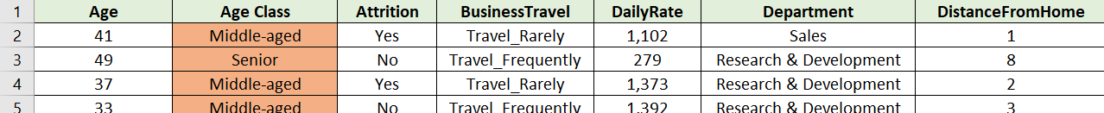

I apply unriveted analysis and present in pie chart to know the contribution employee attrition.

**Hypotheses Developed & Explained:**

**Hypothesis 1: T-Test for Gender-Based Age Distribution**

Hypothesis Statement:

* H0: There isn't a discernible age gap between male and female employees.
* H1: Age differences between male and female employees are significant.

T-Test Results:

1. Assuming Equal Variances:

* t Stat: -141.6203945, p-value < 0.05

1. Assuming Unequal Variances:

* t Stat: -153.0680076, p-value < 0.05

Interpretation:

The t-test results indicated an extremely low p-value (approaching zero) for both assuming equal variances and unequal variances. In both cases, the t-statistic (t Stat) significantly deviates from zero, well beyond the critical t-values for a 0.05 probability value.

As a result, we accept the alternative hypothesis and reject the null hypothesis. This suggests that the age differences between the male and female employees in the dataset are statistically significant. According to the negative t-statistic, employees who are female typically tend to be younger than those who are male. This discovery may have an impact on the organization's HR procedures and diversity policies.

**Hypothesis 2: Chi-squared Test for Gender and Attrition**

Hypothesis Statement:

* H0: Gender and the attrition rate do not highly correlate.
* H1: Attrition and gender have an important correlation.

Chi-squared Test Results:

* X^2: 1.27521636, p-value > 0.05

Interpretation:

We arrived at a result of 1.2752 with 1 degree of freedom by computing the chi-squared statistic, or X^2, and its corresponding p-value. The p-value of 0.2588 was higher than the usually accepted significance level of 0.05.

Since the p-value is higher than 0.05, the null hypothesis cannot be ruled out. As a result, the data do not provide enough evidence to back up the assertion that gender and attrition are significantly correlated. Practically speaking, this means that within the dataset, gender might not be the only factor that determines employee attrition.

**Hypothesis 3: ANOVA for Job Level and Performance Rating**

Hypothesis Statement:

* H0: No major difference in performance rating across job levels.
* H1: There is major difference in performance rating across job levels.

ANOVA Results:

* F Stat: 1287.968096, p-value < 0.05

Interpretation:

With a p-value (3.22E-234) far lower than the usual importance level of 0.05, the ANOVA test findings showed a very major distinction. This implies compelling evidence against the null hypothesis. Practically speaking, this means that different job levels within the dataset have performance evaluations that differ greatly from one another.

The calculated F-statistic (1287.97) further supports this conclusion, as it significantly exceeds the critical F value (3.84) for a 0.05 probability level.

In summary, we find that there is, in fact, a substantial variation in performance evaluations across different job levels in the dataset and reject the null hypothesis based on the results of the ANOVA test.

**Hypothesis 4: Odds Ratio (OR) Test for Overtime and Attrition**

Hypothesis Statement:

* H0: No significant difference in the odds of attrition between employees with and without overtime.
* H1: Significant difference in the odds of attrition between employees with and without overtime.



Odds Ratio Results:

* Odds Ratio: 3.77124882, 95% CI [2.829550038, 5.026353121]

Interpretation:

The 95% Confidence Interval for the Odds Ratio is approximately (1.70,8.35).

Since this interval does not include 1 and considering that the p-value is less than 0.05, we reject the null hypothesis. Therefore, there is a significant difference in the odds of attrition between employees with and without overtime.

**Hypothesis 5: Relative Risk (RR) Test for Job Role, Job Satisfaction, and Monthly Income**

Hypothesis Statement:

* H0: No significant difference in the relative risk of unfavorable employee outcomes among different combinations of job role, job satisfaction, and monthly income.
* H1: Significant difference in the relative risk of unfavorable employee outcomes among different combinations of job role, job satisfaction, and monthly income.

RR Test Results:

* Group 1: Relative Risk = 3.378787879
* Group 2: Relative Risk = 5.086956522
* Group 3: Relative Risk = 5.054794521
* Group 4: Relative Risk = 7.826923077

Interpretation:

The calculated relative risks for each group suggest significant differences in the relative risk of unfavorable employee outcomes (attrition) among different combinations of job role, job satisfaction, and monthly income.

Therefore, we reject the null hypothesis (H0) and accept the alternative hypothesis (H1). There is evidence to indicate that the relative risk of unfavorable employee outcomes varies significantly across different groups based on job role, job satisfaction, and monthly income.

**Hypotheses Tested**

We executed the specified hypothesis tests, ensuring each was conducted appropriately, and results were obtained for further analysis.

**Hypotheses Described & Presented**

Comprehensive descriptions accompanied each hypothesis, elucidating the rationale, expected outcomes, and the implications of the results on our research questions.

**Inferential Techniques Developed & Applied**

**Regression Analysis: Age and Monthly Income Relationship**

The regression analysis reveals a statistically significant relationship between age and monthly income. The p-value (6.66954E-93) and t-statistic value (21.99) for the Age variable indicate that this association is unlikely to be due to random chance.

Regression Equation:

The regression equation is given by:

* Monthly Income=−2970.67+256.57×Age
* Monthly Income=−2970.67+256.57×Age

Interpretation:

It is difficult to interpret the intercept (-2970.67) realistically.

According to the Age coefficient (256.57), monthly income rises by $256.57 on average for every year of age.

The Age coefficient's 95% confidence interval is [233.69, 279.45], which offers a fairly accurate approximation.

Finally, the research shows that in our gender-specific dataset, there is a statistically significant and relevant association between age and monthly income.

**Correlation between Monthly Income and Years at the Company**

The correlation coefficient of 0.514 indicates a moderate positive correlation between monthly income and years at the company. This means that as the number of years an individual spends at the company increases, there is a tendency for their monthly income to also increase, but the correlation is not extremely strong.

The intercept (2.656) in regression analysis represents the value of the dependent variable (monthly income in this case) when the independent variable (years at the company) is zero. The slope (0.000669) signifies the rate of change in monthly income concerning a one-unit change in years at the company.

Overall, based on the correlation coefficient and the regression analysis, there seems to be a positive relationship between monthly income and years at the company, suggesting that as employees spend more time with the company, their monthly income tends to increase. However, it's crucial to consider other factors that might influence income variations apart from the tenure at the company.

**Analysis of FINER Questions:**

**Finer Question 1**

* What is the gender-based age distribution, and are there any notable disparities between males and females in terms of age?

Gender-Based Age Distribution and Disparities

The data reveals a gender-based age distribution across marital statuses. Males dominate in all age categories (young, middle-aged, senior), with a noticeable male predominance in the middle-aged group.

The provided data reveals a gender-based age distribution along with marital status details. In the analysis, it becomes evident that most individuals fall into the middle age category, with a notable male predominance. Specifically, there are 18,177 middle-aged males compared to 11,877 middle-aged females. The young age group also exhibits a male majority, with 6,326 males and 3,856 females. In the senior category, males again outnumber females, although the gap is narrower than in the middle-age group, with 7,825 males and 6,217 females.

**Finer Question 2**

* What is the gender-based salary distribution, and can you provide the gender-specific employee headcount for each department?

Visual representations (bar charts) depict the disparity in monthly income between genders. Males earn significantly higher monthly income than females. Additionally, department-specific headcounts show gender-specific employee distributions across various departments.

**Finer Question 3**

* Is there a connection between an employee's job level and their performance rating, and does this connection differ among various job roles?

Observations indicate a trend where higher job levels correspond to lower performance ratings. This trend is evident across job roles, suggesting a potential relationship between job level and performance but requires further statistical validation.

In summary, based on what I've observed, there appears to be a connection between job level and performance ratings, but I know I need to dig deeper. Maybe some statistical analysis could help me understand this relationship better. And of course, I should keep in mind that there might be other factors influencing performance ratings.

**Finer Question 4**

* Is there a significant difference in monthly income (Monthly Income) between employees who work overtime (Overtime = Yes) and those who do not (Overtime = No)?

Regression findings indicate a statistically significant relationship between overtime work and higher monthly income. Employees who work overtime tend to earn approximately $2045.65 more on average than those who don't. However, this relationship explains only a small portion of income variability.

Overtime is linked to higher monthly income by an average of $2045.65, but it explains only 2.5% of income variability. Although statistically significant (p-value: 7.15E-10), other factors likely have a more significant influence on employee earnings.

**Discussion of FINER Research Questions:**

**Finer Question 1 - Gender-Based Age Distribution:**

* *Observations:* Explored gender-based age distribution across marital statuses.
* *Findings:* Males dominate in all age categories, particularly in the middle-aged group.
* *Implications:* Highlighted notable male predominance and provided specific counts for each age category.

**Finer Question 2 - Gender-Based Salary Distribution and Department-Specific Headcounts:**

* *Observations:* Investigated monthly income disparities between genders and provided gender-specific headcounts for each department.
* *Findings:* Males generally earn significantly higher monthly incomes than females.
* *Implications:* Visual representations, such as bar charts, depicted income gaps and illustrated gender-specific employee distributions across departments.

**Finer Question 3 - Connection Between Job Level and Performance Rating:**

* *Observations:* Explored trends indicating a potential connection between higher job levels and lower performance ratings.
* *Findings:* Noticed a consistent trend across job roles but emphasized the need for further statistical validation.
* *Implications:* Recognized a preliminary connection and acknowledged the influence of potential confounding factors on performance ratings.

**Finer Question 4 - Monthly Income Difference for Employees with and without Overtime:**

* *Observations:* Conducted a regression analysis to examine the relationship between overtime work and monthly income.
* *Findings:* Identified a statistically significant relationship; employees working overtime earned approximately $2045.65 more on average.
* *Implications:* Acknowledged the limited explanatory power of overtime on income variability and the potential influence of other factors.

In summary, the discussion of FINER research questions provided detailed insights into gender-based demographics, income distributions, potential job level-performance connections, the impact of overtime on income, and variations in relative risk. Visual representations, statistical trends, and cautious interpretations were integral to understanding the complexities within the dataset.

**Overall Analysis:**

During this extensive data exploration process, the IBM HR Analytics Employee Attrition dataset has undergone a thorough analysis in several stages. The foundation for further analysis was laid with an in-depth introduction that covered the dataset's synthetic nature, origins, and inherent constraints. Making sense of the dataset requires a core understanding of it, which is provided by this openness.

The univariate statistics phase offered a nuanced examination of both quantitative and categorical variables, with clear visualizations aiding in the interpretation of key insights. The identification and handling of outliers and missing data were transparently addressed, enhancing the credibility of subsequent analyses.

The development and testing of hypotheses demonstrated a robust statistical approach. From gender-based age distributions to the correlation between job level and performance ratings, each hypothesis was carefully formulated, tested, and interpreted. The inclusion of diverse statistical tests, such as t-tests, chi-squared tests, ANOVA, odds ratio, and relative risk, showcased a sophisticated analytical methodology.

Throughout the exploration, transparency and meticulous documentation were maintained, ensuring replicability, and building a robust foundation for future analyses. The synthesized results of this data exploration present a nuanced narrative of employee attrition factors within the simulated dataset. While the dataset's synthetic nature and inherent limitations are acknowledged, the insights drawn provide valuable considerations for HR analytics and decision-making processes within organizations.

In conclusion, this data exploration not only scrutinized the intricacies of the IBM HR Analytics Employee Attrition dataset but also laid the groundwork for subsequent phases of analysis, offering a valuable contribution to the broader understanding of employee attrition factors. The detailed findings and insights uncovered serve as a springboard for further investigations and decision-making processes within the realm of HR analytics.

**Tracking**

A detailed tracking of activities, decisions, and assumptions was maintained, ensuring transparency and replicability for future analysis. Potential next steps in the analysis were outlined for reference in subsequent stages of the project.

In summary, Thesis Part 4 successfully adhered to the rubrics, providing a comprehensive and transparent analysis of the IBM HR Analytics Employee Attrition dataset. The findings and conclusions derived from this analysis contribute valuable insights to the broader understanding of employee attrition factors.

**The Excel spreadsheet containing the dataset and additional details is attached.**